**H&T Final Project Overview Document**

This document will cover the mechanics for Hare and Tortoise and how I will be going about implementing them in Unity.

**Currency system**

The currency system is used for the player’s movement throughout the game. More currency is spent by the player moving more spaces, following the triangular number sequence. This is shown in the picture for the 2010 version of Hare and Tortoise below:



Figure 1: Picture of the cost to move to the number of squares you can move

As I stated during my planning stage for the Hare and Tortoise there is no version of the game online nor any digital version to look at to see how other developers may have attempted to make the mechanics for the game, therefore I need to look at similar games with similar systems to get an idea of what they did.

The main digital game example for a currency system like Hare and Tortoise is Monopoly (Hasbro, 2018) – each player has their own money which they use throughout the game to buy squares, property and pay other players if they land on another player’s square. Monopoly will be a good game to look at as the currency system is similar in Hare and Tortoise, however movement in Monopoly is done by a roll of a die instead.

**Movement mechanics**

Hare and Tortoise movement mechanics work alongside the currency system, where the player requires currency to move. However, the movement works like many other games on the market where players choose what tile to move their piece to (so long as they can afford it).

The one unique mechanic that differentiates Hare and Tortoise to the other racing board games is the ability to move backwards to a certain tile to gain currency. This allows the player to gain 10 currencies for every square they move back to the ‘tortoise tile’.

Games that I have been looking at are:

Chess (Chess.com, 2018) – Each individual piece in chess is only allowed to move in certain directions, for example, the pawn can only move forward or if there’s an enemy one square diagonally from them they can take the piece. This limitation of movement could be useful for Hare and Tortoise as I could only show what squares the player could move to during their turn via how much it would cost.

D&D: Castle Ravenloft board game (DnD Wizards, 2018) – in this board game version of D&D each character can move a certain amount of spaces during their turn in any direction. This is determined by the speed of the character (speed budget) which once they move they can then choose to do another action. This could be used in Hare and Tortoise for the turn based system where each player can decide per turn what they want to do next (although for now it’ll just be moving forwards or backwards, in the full game they could then choose to stay on a carrot card for example).

XCOM game series (Fraxis Games, 2012) – Similar to D&D. The game uses click-to-move movement where the player clicks the tile they want to move their character to and the character will move if the game time is running. The game will stop if the character is not moving to allow the player to choose what actions to do next. This relates to Hare and Tortoise as it gives the player the ability to decide what they’re doing next and then let them see what they did after the decision is made.

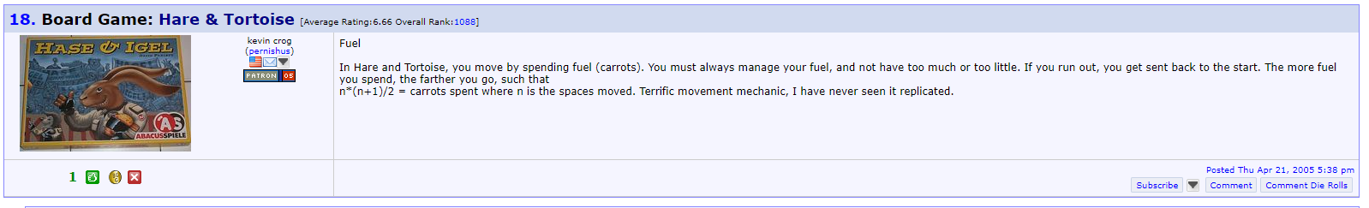

Figure 2: Image from BoardGameGeek describing the 'Point A to Point B' movement in Hare and Tortoise (BoardGameGeek, 2005)

**Turned based mechanics**

There are many examples for how the turn based system works in games. The game will go between each player to carry out their turn. Once the player has made their turn the game will focus on the next player to make their turn. Most racing games and board games incorporate turn based mechanics, for example Monopoly, Snakes and Ladders [5], Ludo and Ticket to Ride.

**References**

BoardGameGeek (2005). *From Point A to Point B >> A Look at Movement Mechanics | BoardGameGeek*. [online] Boardgamegeek.com. Available at: https://boardgamegeek.com/geeklist/7619/point-point-b-look-movement-mechanics [Accessed 21 Jun. 2018].

Chess.com (2018). *How to Play Chess: Rules and Basics*. [online] Chess.com. Available at: https://www.chess.com/learn-how-to-play-chess [Accessed 21 Jun. 2018].

Days of Wonder (2012). *Ticket to Ride on Steam*. [online] Store.steampowered.com. Available at: https://store.steampowered.com/app/108200/Ticket_to_Ride/ [Accessed 21 Jun. 2018].

DnD Wizards (2018). *Castle Ravenloft Rulebook*. [online] Dnd.wizards.com. Available at: https://dnd.wizards.com/sites/default/files/media/Castle_Ravenloft_RuleBook.pdf [Accessed 21 Jun. 2018].

Fraxis Games (2012). *XCOM: Enemy Unknown on Steam*. [online] Store.steampowered.com. Available at: https://store.steampowered.com/app/200510/XCOM_Enemy_Unknown/ [Accessed 21 Jun. 2018].

Games.co.uk (2018). *Snakes and Ladders*. [online] games.co.uk. Available at: http://www.games.co.uk/game/snakes-and-ladders [Accessed 21 Jun. 2018].

Hasbro (2018). *Monopoly*. [online] Hasbro.com. Available at: https://www.hasbro.com/en-gb/brands/monopoly [Accessed 21 Jun. 2018].

Ludo (2017). *Ludo Game*. [online] Ludo King Game Online. Available at: http://ludokinggames.com/ludo-game [Accessed 21 Jun. 2018].